TELECOM CUSTOMER CHURN
INTELLIGENCE & RETENTION ANALYTICS
An End-to-End Data Analytics Project using SQL, Python & Power BI
Project Report
Tools Used: MySQL Workbench | Python (Pandas) | Power BI Desktop

1. Project Overview & Business Problem
Customer churn — when a subscriber discontinues service — is one of the most expensive problems a telecom company faces. Acquiring a new customer typically costs 5 to 7 times more than retaining an existing one, which makes early identification of at-risk customers a high-value business capability.
This project simulates the role of a Data Analyst embedded in a telecom company's retention team. The goal was not just to build charts, but to answer a specific business question end-to-end: which customers are likely to leave, why they are leaving, and how much revenue is at stake — so the retention team can act with the right priority and the right offer.
Business Objective
Identify the key drivers of customer churn and segment high-risk customers, so the business can prioritize retention efforts and reduce revenue loss.

Key Questions the Project Answers
- Who is churning? — churn rate overall and across contract type, payment method, and tenure.
- Why are they churning? — the relationship between support tickets, service add-ons, and churn.
- Which active customers are highest-risk right now, and how much annual revenue do they represent?
- What should the business act on first? — a prioritized, revenue-ranked retention list.

2. Data Overview
The analysis is built on a relational database (telecom_churn) modelled the way a real telecom's backend would store customer data — normalized across five related tables rather than a single flat file, which required genuine SQL joins to assemble a usable dataset.

Database Schema
- customers (7,043 rows) — demographic details: gender, senior citizen flag, partner/dependents, signup date.
- accounts (7,043 rows) — contract type, billing method, monthly/total charges, and the churn label itself.
- services (7,043 rows) — which add-ons each customer subscribes to (security, backup, tech support, streaming, etc.).
- support_tickets (10,525 rows) — every support interaction logged per customer, with issue type and satisfaction score.
- monthly_usage (121,127 rows) — month-by-month data, call, and SMS usage per customer.

All tables are linked by a common customer_id key, following a one-to-many relationship from customers into the ticket and usage logs — mirroring how usage and support data accumulate over a customer's lifetime in a real production system.

Core Column Dictionary (selected)
Column | Meaning
customer_id | Unique identifier for each customer; the primary key linking all five tables.
tenure_months | Number of months the customer has been with the company.
contract_type | Month-to-month, One year, or Two-year contract.
monthly_charges / total_charges | Recurring monthly bill and cumulative lifetime billing.
churn | Target variable — 'Yes' if the customer has left, 'No' if still active.
internet_service | DSL, Fiber optic, or No internet — many add-ons only apply when this is not 'No'.
total_tickets | Number of support tickets raised by the customer (engineered from support_tickets).
avg_satisfaction_score | Average post-resolution satisfaction rating (1–5) across the customer's tickets.
avg_monthly_data_gb / avg_monthly_call_minutes | Average monthly usage, engineered from monthly_usage.

3. Tools & Workflow
The project follows a standard industry pipeline, with each tool used for what it is best at:
- MySQL Workbench — data storage, exploration, and multi-table extraction via SQL.
- Python (Pandas, NumPy) — data cleaning, missing-value treatment, and feature engineering.
- Power BI Desktop — DAX measures and an interactive two-page executive dashboard.

4. Phase 1 — SQL: Data Exploration & Extraction
Before any cleaning, the raw data was explored directly in the database to understand its shape, check for structural issues, and validate early business assumptions. SQL was deliberately used only for exploration and extraction — not deep cleaning — since Python's Pandas library offers more flexible, auditable cleaning logic.

4.1 Structural Checks
Row counts across all five tables, to confirm expected volume and that no table was empty or partially loaded:

SELECT 'customers' AS table_name, COUNT(*) AS row_count FROM customers
UNION ALL
SELECT 'accounts', COUNT(*) FROM accounts
UNION ALL
SELECT 'services', COUNT(*) FROM services
UNION ALL
SELECT 'support_tickets', COUNT(*) FROM support_tickets
UNION ALL
SELECT 'monthly_usage', COUNT(*) FROM monthly_usage;

Duplicate key check, to confirm customer_id is safe to use as a join key:

SELECT customer_id, COUNT(*)
FROM customers
GROUP BY customer_id
HAVING COUNT(*) > 1;
-- Result: 0 rows returned — no duplicate customer IDs

4.2 Early Business Insight Queries
Overall churn rate — the single most important baseline number for the whole project:

SELECT
churn,
COUNT(*) AS customers,
ROUND(COUNT(*) * 100.0 / SUM(COUNT(*)) OVER (), 2) AS pct
FROM accounts
GROUP BY churn;
-- Result: 26.54% of customers have churned

Churn rate by contract type — the first real driver identified:

SELECT
contract_type,
COUNT(*) AS total_customers,
SUM(CASE WHEN churn = 'Yes' THEN 1 ELSE 0 END) AS churned,
ROUND(SUM(CASE WHEN churn = 'Yes' THEN 1 ELSE 0 END) * 100.0
/ COUNT(*), 2) AS churn_rate_pct
FROM accounts
GROUP BY contract_type
ORDER BY churn_rate_pct DESC;

This query immediately surfaced the strongest pattern in the dataset: month-to-month customers churn at a dramatically higher rate than one- or two-year contract holders — a finding later confirmed and visualized on the dashboard.
Support ticket volume — churned vs. retained customers, using a correlated subquery joined back to accounts:

SELECT
a.churn,
ROUND(AVG(t.ticket_count), 2) AS avg_tickets
FROM accounts a
LEFT JOIN (
SELECT customer_id, COUNT(*) AS ticket_count
FROM support_tickets
GROUP BY customer_id
) t ON a.customer_id = t.customer_id
GROUP BY a.churn;

4.3 The Master Extraction Query
The final SQL step joins all five tables into a single, analysis-ready extract. INNER JOINs are used for accounts and services because every customer has exactly one row in each (a 1-to-1 relationship), while LEFT JOINs are used for support_tickets and monthly_usage because not every customer has raised a ticket or logged usage — an INNER JOIN there would have silently dropped real customers from the dataset. Each of those two tables is first aggregated to one row per customer via a subquery before joining, and COALESCE() is used to convert missing ticket counts to a genuine 0, while leaving missing satisfaction scores as NULL (since a customer with zero tickets doesn't have an unknown satisfaction — the metric simply doesn't apply to them).

SELECT
c.customer_id,
c.gender,
c.senior_citizen,
c.partner,
c.dependents,
c.signup_date,
a.tenure_months,
a.contract_type,
a.paperless_billing,
a.payment_method,
a.monthly_charges,
a.total_charges,
a.churn,
s.phone_service,
s.multiple_lines,
s.internet_service,
s.online_security,
s.online_backup,
s.device_protection,
s.tech_support,
s.streaming_tv,
s.streaming_movies,
COALESCE(t.ticket_count, 0) AS total_tickets,
COALESCE(t.avg_satisfaction, NULL) AS avg_satisfaction_score,
COALESCE(u.avg_data_gb, NULL) AS avg_monthly_data_gb,
COALESCE(u.avg_call_minutes, NULL) AS avg_monthly_call_minutes
FROM customers c
JOIN accounts a ON c.customer_id = a.customer_id
JOIN services s ON c.customer_id = s.customer_id
LEFT JOIN (
SELECT customer_id, COUNT(*) AS ticket_count,
AVG(satisfaction_score) AS avg_satisfaction
FROM support_tickets
GROUP BY customer_id
) t ON c.customer_id = t.customer_id
LEFT JOIN (
SELECT customer_id, AVG(data_gb) AS avg_data_gb,
AVG(call_minutes) AS avg_call_minutes
FROM monthly_usage
GROUP BY customer_id
) u ON c.customer_id = u.customer_id;

AVG() was used deliberately instead of SUM() for the usage metrics, because customers have widely different tenures. Summing usage would make a long-tenured customer look far more "active" than a short-tenured but heavier user, purely as an artifact of time. Averaging normalizes usage to a per-month basis, giving a genuine behavioral signal rather than a tenure-biased one.
The result of this query was exported to CSV and became the single input file for the Python cleaning stage.

5. Phase 2 — Python: Data Cleaning & Feature Engineering
The SQL extract was loaded into Pandas for inspection, cleaning, and the creation of dashboard-ready features.

5.1 Initial Inspection

import pandas as pd

df = pd.read_csv("telecom_extract_SQL.csv")

df.shape # (7043, 25)
df.info() # data types + non-null counts
df.isnull().sum() # missing values per column
df.duplicated().sum() # 0 duplicate rows found

Two issues surfaced from inspection: signup_date was loaded as a generic object/string rather than a date, and three columns had missing values — avg_satisfaction_score, avg_monthly_data_gb, and avg_monthly_call_minutes.

5.2 Data Type Correction

df['signup_date'] = pd.to_datetime(df['signup_date'])

5.3 Missing Value Treatment
Rather than applying a single blanket rule, each column's missing values were traced back to their cause and handled accordingly:
- avg_monthly_data_gb / avg_monthly_call_minutes — missing because the customer has no rows in monthly_usage, which genuinely means zero usage. Filled with 0.
- avg_satisfaction_score — missing because the customer never raised a support ticket. This is not a zero rating, it is an unknown one, so a flag column was created and the value was filled with a neutral placeholder for downstream reporting rather than being treated as "worst possible" satisfaction.
# Flag: does this customer have any ticket history at all?
df['has_support_ticket'] = df['avg_satisfaction_score'].notnull().map(
{True: 'Yes', False: 'No'}
)

# Usage columns — missing genuinely means zero usage
df['avg_monthly_data_gb'] = df['avg_monthly_data_gb'].fillna(0)
df['avg_monthly_call_minutes'] = df['avg_monthly_call_minutes'].fillna(0)
# Satisfaction score — filled for reporting, always paired with the flag
# above so it is excluded from any 'true average satisfaction' calculation
df['avg_satisfaction_score'] = df['avg_satisfaction_score'].fillna(0)

df.isnull().sum() # confirms 0 remaining nulls

5.4 Feature Engineering for the Dashboard
Since the project's final output is a Power BI dashboard rather than a predictive model, feature engineering focused on creating fields that make strong, filterable visuals rather than model-ready numeric encodings:

# Tenure buckets — for clean slicers and grouped charts
def tenure_bucket(months):
if months <= 12: return "0-1 Year"
elif months <= 24: return "1-2 Years"
elif months <= 48: return "2-3 Years"
elif months <= 60: return "3-4 Years"
else: return "4+ Years"

df['tenure_bucket'] = df['tenure_months'].apply(tenure_bucket)

# Revenue at risk — projected annual value of churned accounts
df['annual_revenue_at_risk'] = df.apply(
lambda r: r['monthly_charges'] * 12 if r['churn'] == 'Yes' else 0,
axis=1
)

# Add-on engagement score — how many optional services a customer has
addon_cols = ['online_security', 'online_backup', 'device_protection',
'tech_support', 'streaming_tv', 'streaming_movies']
df['total_addons_subscribed'] = df[addon_cols].apply(
lambda row: sum(1 for v in row if v == 'Yes'), axis=1
)

# Binary churn flag — simplifies DAX measures in Power BI
df['is_churned'] = df['churn'].map({'Yes': 1, 'No': 0})
df.to_csv("telecom_churn_cleaned.csv", index=False)
# Cleaned file saved! Shape: (7043, 31)
The cleaned file grew from 25 to 31 columns — the six new engineered fields are what allow the dashboard to filter by tenure bucket, rank customers by revenue at risk, and segment by service engagement without a single DAX calculated column being needed in Power BI.

6. Phase 3 — Power BI: Dashboard Story
The cleaned CSV was loaded into Power BI Desktop and built into a two-page interactive dashboard. The two pages are intentionally structured around two different audiences and two different questions: Page 1 answers 'what is happening and what is it costing us' for leadership, and Page 2 answers 'why is it happening and who do we act on first' for the retention operations team.

6.1 Page 1 — Executive Overview
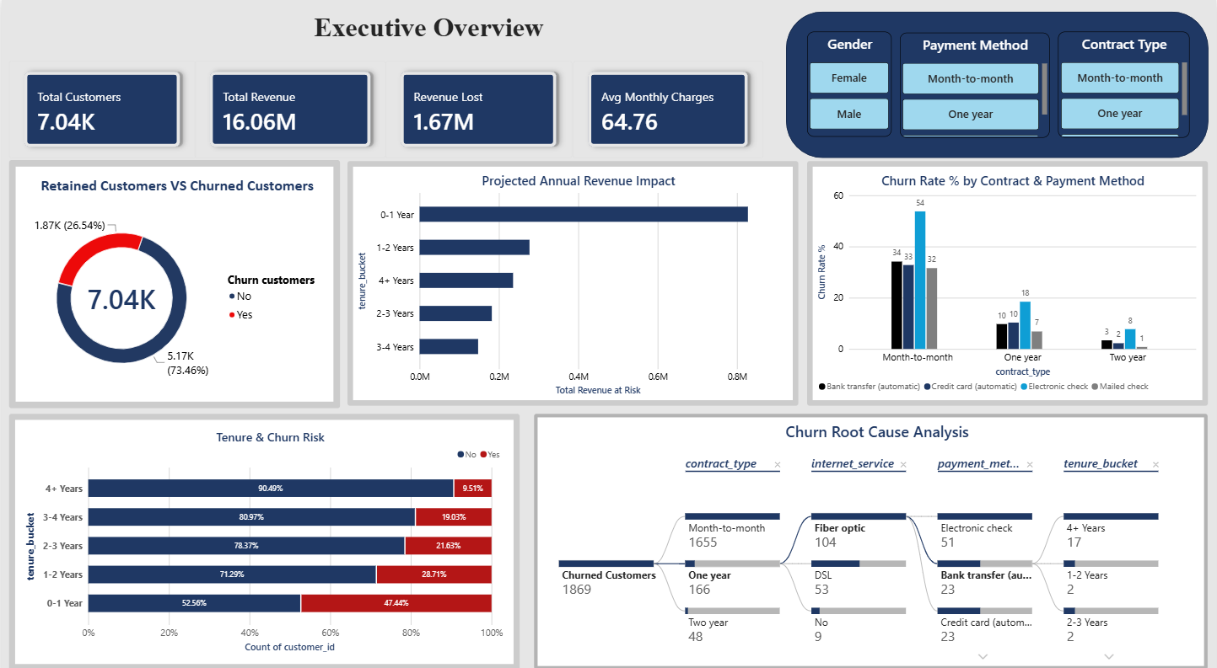
Figure 1 — Executive Overview page, showing headline KPIs, churn split, revenue impact by tenure, and root-cause decomposition.
This page opens with four KPI cards — Total Customers, Total Revenue, Revenue Lost, and Average Monthly Charges — giving leadership an immediate financial snapshot before any drill-down. The donut chart below confirms the baseline metric established in SQL: a 26.54% churn rate, with 5.17K customers retained against 1.87K lost.
The 'Projected Annual Revenue Impact' chart breaks that loss down by tenure bucket, and is the clearest financial argument in the dashboard: customers in their first year account for the single largest share of revenue impact — meaning retention spend is most valuable when targeted early in the customer lifecycle, not evenly across all tenures.
The 'Tenure & Churn Risk' stacked bar makes the same point behaviorally rather than financially: churn rate falls from 47.44% in the 0–1 Year bucket down to just 9.51% for customers past 4 years. This single visual is arguably the strongest insight in the whole project — the risk of losing a customer drops sharply the longer they stay, which reframes the business problem from 'stop churn everywhere' to 'protect the first 12 months.'
The decomposition tree in the bottom-right lets a viewer interactively drill from contract type, into internet service, into payment method, into tenure bucket — reproducing, as an exploratory tool, the same layered questions that were first asked in SQL (Section 4.2).

6.2 Page 2 — Churn Rate & Retention Operations
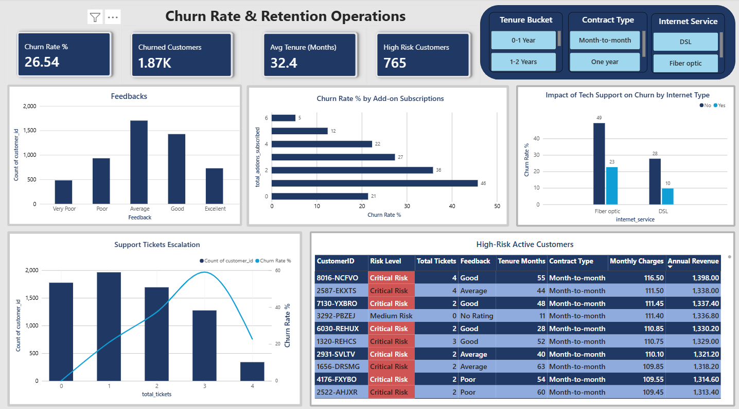
Figure 2 — Retention Operations page, showing root-cause diagnostics and a revenue-ranked, action-ready customer list.
Where Page 1 tells leadership what is happening, Page 2 is built for the team that has to act on it. The 'Impact of Tech Support on Churn by Internet Type' chart isolates one of the clearest levers in the dataset: Fiber optic customers without Tech Support churn at roughly 49%, compared to about 23% for those who have it — nearly a 2x difference from a single add-on. The same pattern holds, at a smaller scale, for DSL customers.
'Churn Rate % by Add-on Subscriptions' generalizes that finding: churn rate falls in almost a straight line as customers subscribe to more optional services, from roughly 46% churn rate at zero add-ons down to single digits at six. This directly informs a retention offer strategy — bundling a free trial of security or tech-support add-ons for new, add-on-light customers is a data-backed intervention, not a guess.
The 'Support Tickets Escalation' combo chart overlays churn rate (line) on ticket volume (bars) and shows churn rate climbing as ticket count rises from 0 to 3 before customer volume itself drops off — visual confirmation of the SQL finding in Section 4.2 that churned customers raise more support tickets on average than retained ones.
The dashboard closes with the 'High-Risk Active Customers' table — deliberately the last visual a viewer's eye reaches, because it is the action item. It is restricted to customers who are still active (churn = 'No') but flagged Critical Risk, and is sorted by Annual Revenue descending rather than by customer ID, so the retention team's very first row is also their highest-value save opportunity.

7. Key Findings
- Overall churn rate is 26.54% — roughly 1 in 4 customers has left, well above what would be considered healthy for a subscription-based service.
- Contract type is the single strongest churn driver: month-to-month customers churn at far higher rates than one- or two-year contract holders.
- Churn risk is heavily front-loaded — 47.44% of customers in their first year churn, compared to 9.51% for customers with 4+ years tenure.
- Fiber optic customers without Tech Support churn at nearly double the rate of those with it (~49% vs ~23%).
- Churn rate declines almost linearly as customers adopt more optional add-on services.
- Customers who raise more support tickets churn at a visibly higher rate, peaking around 3 tickets before customer volume itself thins out.
- A small, identifiable segment of active, high-value, Critical Risk customers can be ranked by revenue and targeted first.

8. Business Recommendations
- Prioritize retention offers in the first 12 months of the customer lifecycle rather than spreading effort evenly across all tenures.
- Incentivize migration from month-to-month to annual contracts (e.g., a discount for the first renewal) given the sharp churn-rate gap between contract types.
- Bundle a free or discounted Tech Support trial for new Fiber optic customers, where the add-on's impact on churn is largest.
- Route customers with 2+ support tickets into a proactive retention workflow rather than waiting for a cancellation request.
- Action the High-Risk Active Customers table directly — it is already sorted by revenue impact and ready for outreach.

9. Conclusion
This project demonstrates a complete, realistic data analytics workflow: a normalized multi-table database queried with SQL, a documented and justified data-cleaning process in Python, and a two-page Power BI dashboard designed around two distinct audiences and decisions rather than as a generic collection of charts. Every number on the dashboard — the churn rate, the revenue-at-risk figures, the add-on and support-ticket patterns — traces back to a specific, explainable step in the SQL or Python code in this report.

